HTML Link Element

📘 Definition
# Source: AI Source: Provided by: [Data Path: Persons Table -> ID Column: 1, Name_En Column: Motasem Essam] -> From: [ChatGPT] on [5/6/2026]
The <link> element is placed inside the <head> and is used to connect your HTML page to external files like CSS, icons, fonts, and more.

⚙️ Common Uses of <link> Element (with examples)

🎨 1. Linking External CSS (Stylesheet)
# Source: AI Source: Provided by: [Data Path: Persons Table -> ID Column: 1, Name_En Column: Motasem Essam] -> From: [ChatGPT] on [5/6/2026]
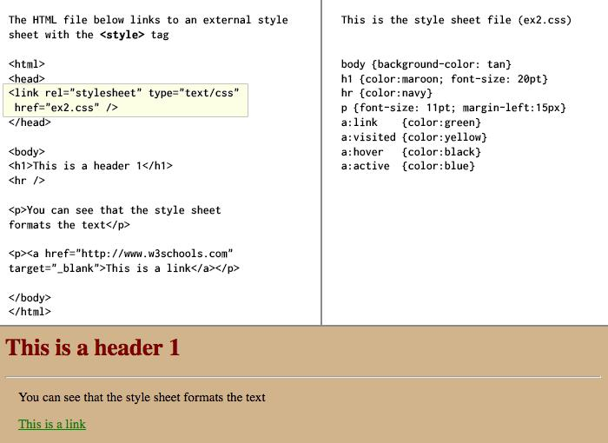
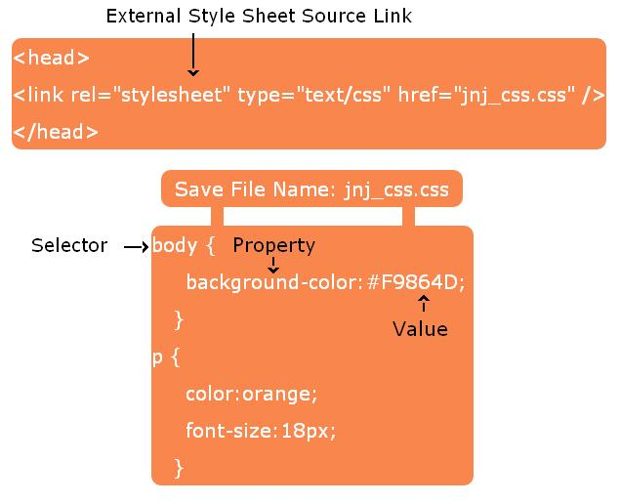
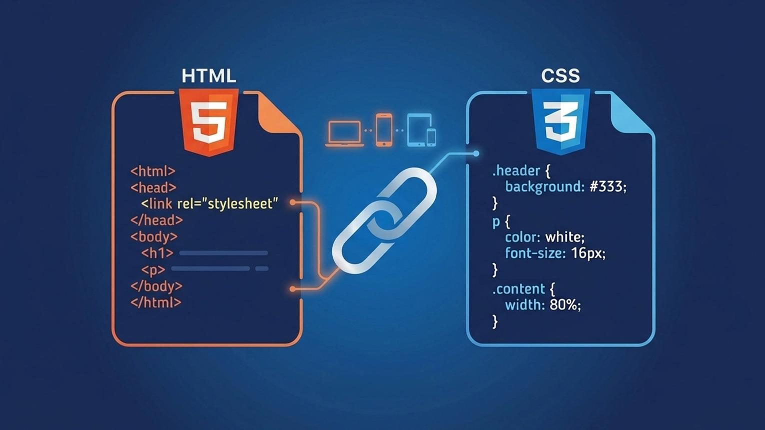

Full Example
# Source: AI Source: Provided by: [Data Path: Persons Table -> ID Column: 1, Name_En Column: Motasem Essam] -> From: [ChatGPT] on [5/6/2026]
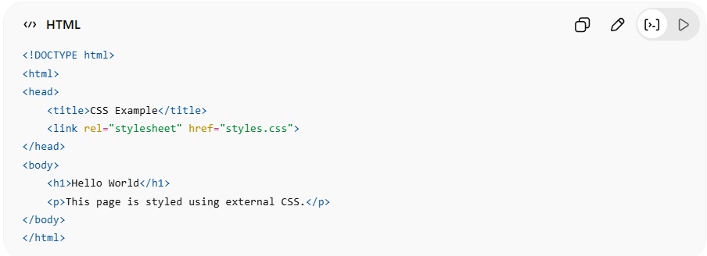
<!DOCTYPE html>
<html>
<head>
<title>CSS Example</title>
<link rel="stylesheet" href="styles.css">
</head>
<body>
<h1>Hello World</h1>
<p>This page is styled using external CSS.</p>
</body>
</html>
👉 This connects your HTML file to a separate CSS file called styles.css.

styles.css (External CSS file)
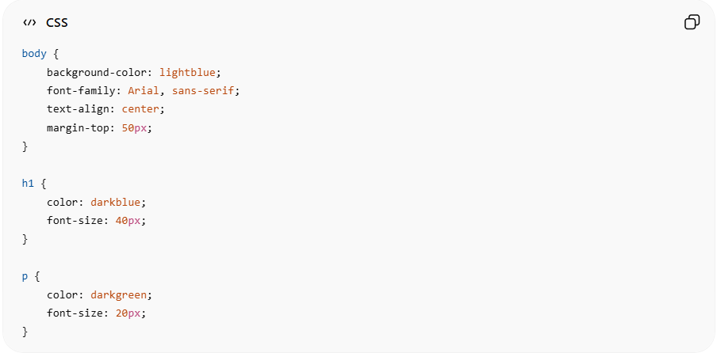
body {
background-color: lightblue;
font-family: Arial, sans-serif;
text-align: center;
margin-top: 50px;
}

h1 {
color: darkblue;
font-size: 40px;
}

p {
color: darkgreen;
font-size: 20px;
}

Real Example
# Source: ScreenShot Source: Provided by: [Persons Table -> ID Column: 1, Name_En Column: Motasem Essam] -> Tool: [Automation Table -> ID Column: 16, Name_En Column: Screen Capture] -> From [Operating System: Windows] on [5/6/2026]
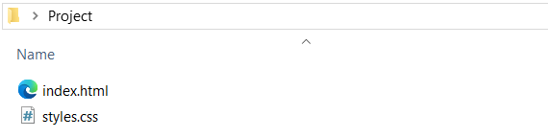
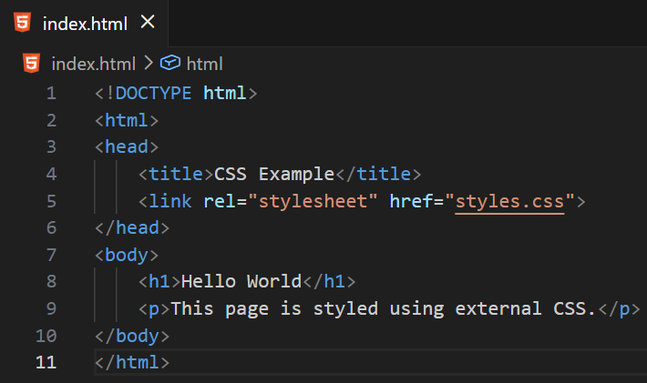
<!DOCTYPE html>
<html>
<head>
<title>CSS Example</title>
<link rel="stylesheet" href="styles.css">
</head>
<body>
<h1>Hello World</h1>
<p>This page is styled using external CSS.</p>
</body>
</html>
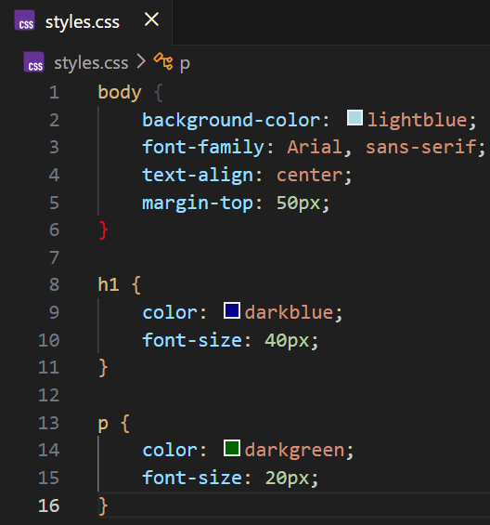
body {
background-color: lightblue;
font-family: Arial, sans-serif;
text-align: center;
margin-top: 50px;
}

h1 {
color: darkblue;
font-size: 40px;
}

p {
color: darkgreen;
font-size: 20px;
}
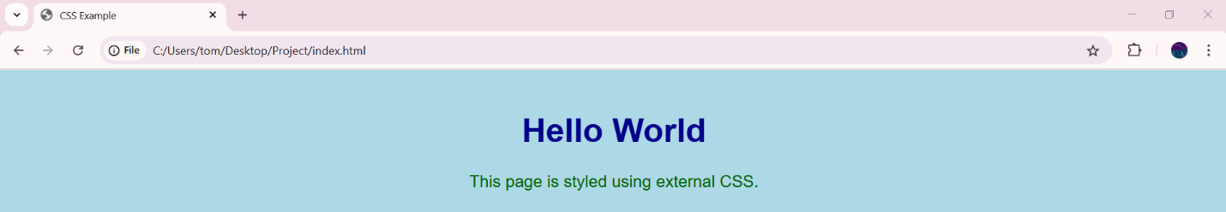

🖼️ 2. Adding a Favicon (Website Icon)
# Source: AI Source: Provided by: [Data Path: Persons Table -> ID Column: 1, Name_En Column: Motasem Essam] -> From: [ChatGPT] on [5/3/2026]
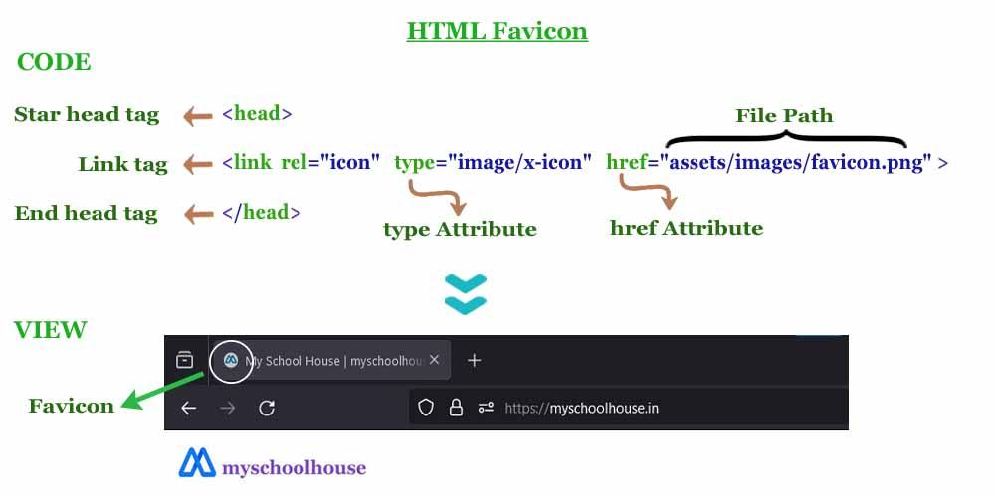



Full Example
# Source: AI Source: Provided by: [Data Path: Persons Table -> ID Column: 1, Name_En Column: Motasem Essam] -> From: [ChatGPT] on [5/6/2026]
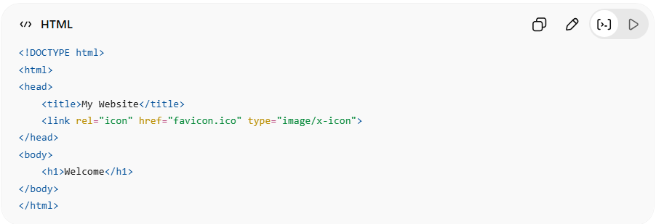
<!DOCTYPE html>
<html>
<head>
<title>My Website</title>
<link rel="icon" href="favicon.ico" type="image/x-icon">
</head>
<body>
<h1>Welcome</h1>
</body>
</html>
👉 This shows a small icon in the browser tab.

Real Example
# Source: ScreenShot Source: Provided by: [Persons Table -> ID Column: 1, Name_En Column: Motasem Essam] -> Tool: [Automation Table -> ID Column: 16, Name_En Column: Screen Capture] -> From [Operating System: Windows] on [5/6/2026]
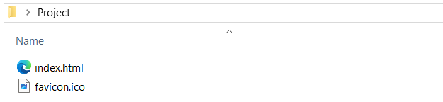
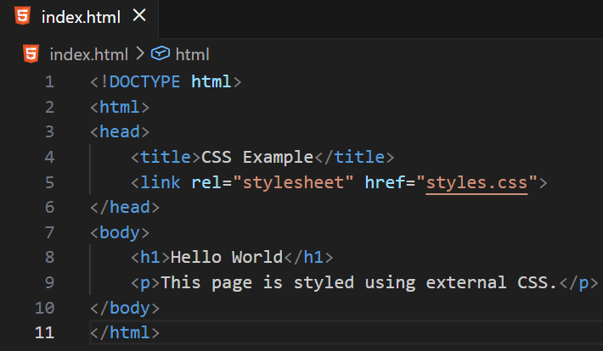
<!DOCTYPE html>
<html>
<head>
<title>CSS Example</title>
<link rel="stylesheet" href="styles.css">
</head>
<body>
<h1>Hello World</h1>
<p>This page is styled using external CSS.</p>
</body>
</html>
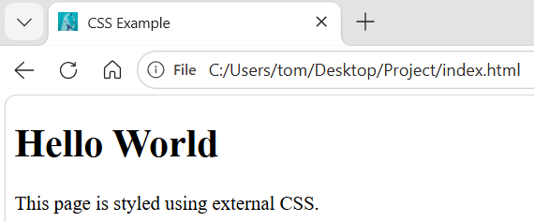

Supported Favicon Formats
# Source: AI Source: Provided by: [Data Path: Persons Table -> ID Column: 1, Name_En Column: Motasem Essam] -> From: [ChatGPT] on [5/6/2026]
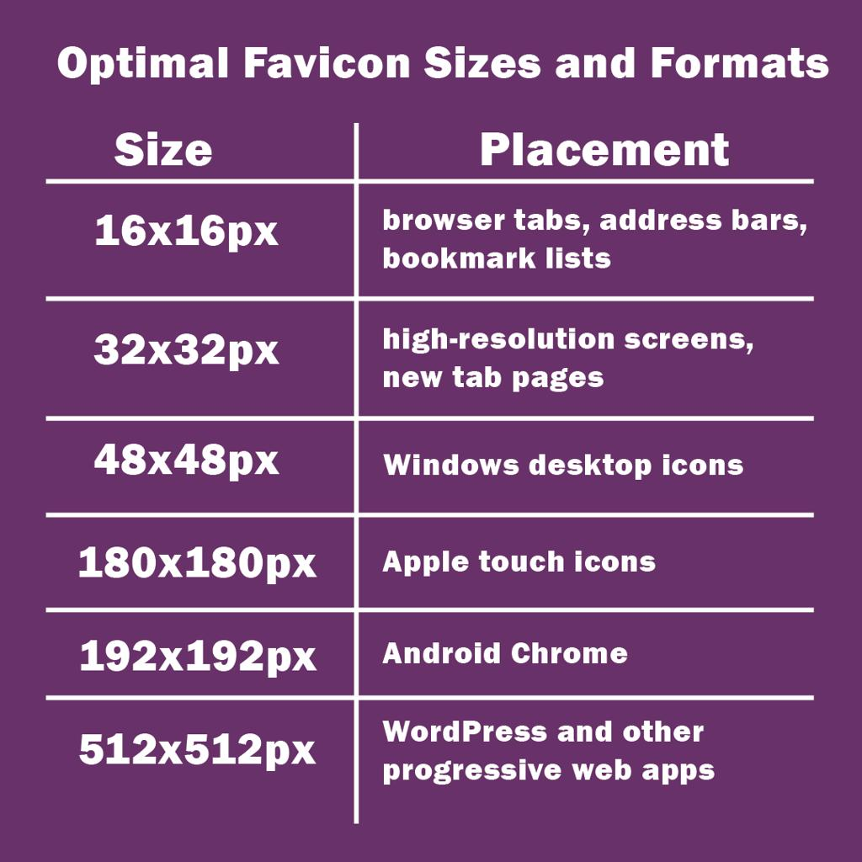
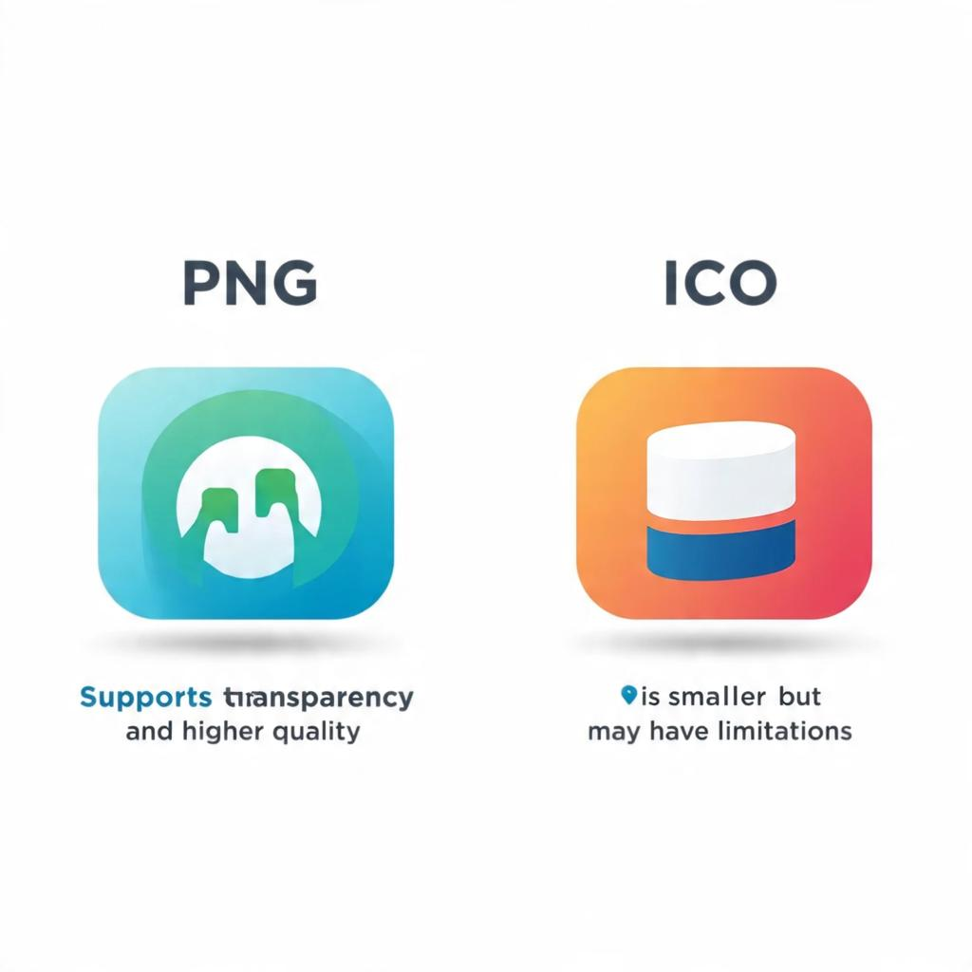
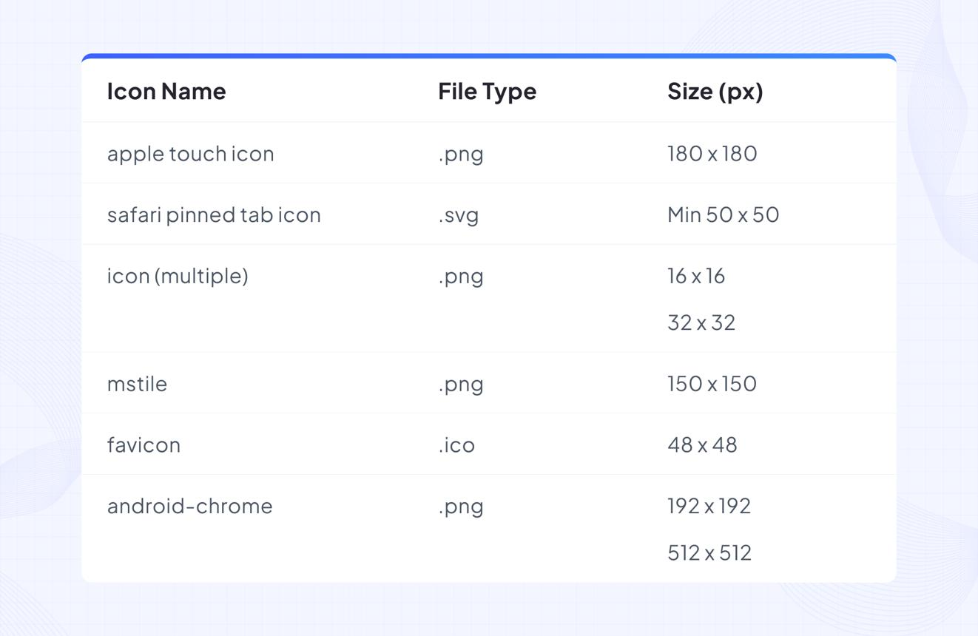
🟢 1. .ico (Most recommended)
- Traditional favicon format
- Works in all browsers
- Can contain multiple sizes in one file
🟢 2. .png
- Modern and very common
- High quality and supports transparency
- Widely supported by all browsers
🟢 3. .svg
- Vector format (scales without losing quality)
- Very sharp on all screen sizes
- Supported by modern browsers
🟡 4. .gif
- Can be used, sometimes supports animation
- Not commonly used for favicons
🔴 5. .jpg / .jpeg
- Not recommended
- No transparency support
- Less sharp for icons
💻 Example Usage
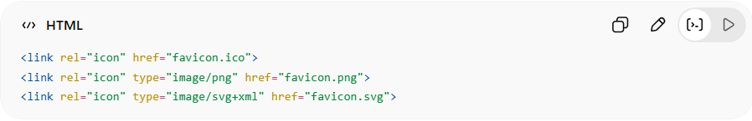
<link rel="icon" href="favicon.ico">
<link rel="icon" type="image/png" href="favicon.png">
<link rel="icon" type="image/svg+xml" href="favicon.svg">

🔤 3. Linking Google Fonts
# Source: AI Source: Provided by: [Data Path: Persons Table -> ID Column: 1, Name_En Column: Motasem Essam] -> From: [ChatGPT] on [5/6/2026]
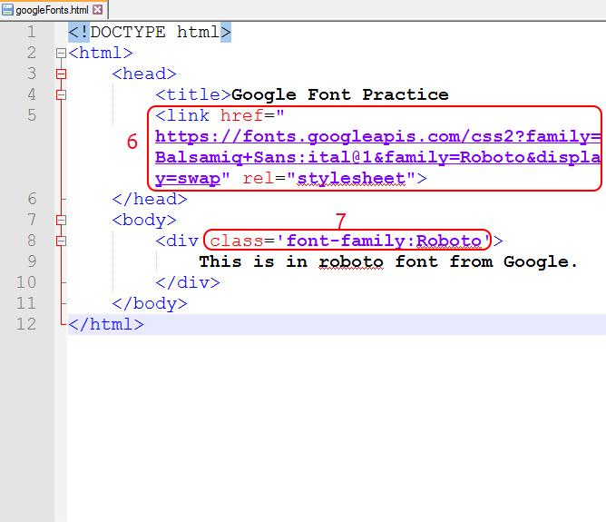
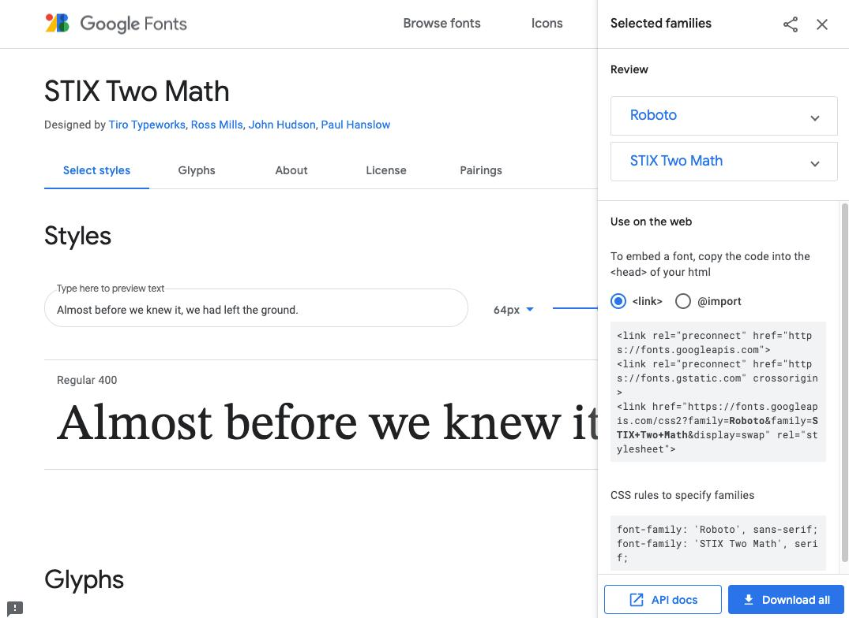
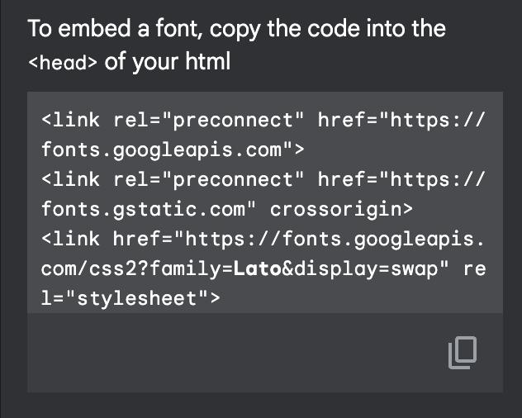

Full Example
# Source: AI Source: Provided by: [Data Path: Persons Table -> ID Column: 1, Name_En Column: Motasem Essam] -> From: [ChatGPT] on [5/6/2026]
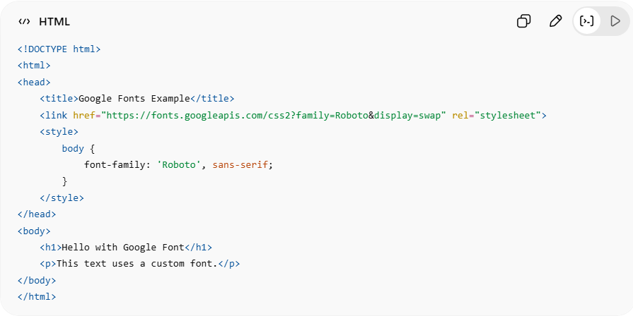
<!DOCTYPE html>
<html>
<head>
<title>Google Fonts Example</title>
<link href="https://fonts.googleapis.com/css2?family=Roboto&display=swap" rel="stylesheet">
<style>
body {
font-family: 'Roboto', sans-serif;
}
</style>
</head>
<body>
<h1>Hello with Google Font</h1>
<p>This text uses a custom font.</p>
</body>
</html>
👉 This loads a custom font from Google Fonts.

Real Example
# Source: ScreenShot Source: Provided by: [Persons Table -> ID Column: 1, Name_En Column: Motasem Essam] -> Tool: [Automation Table -> ID Column: 16, Name_En Column: Screen Capture] -> From [Operating System: Windows] on [5/6/2026]
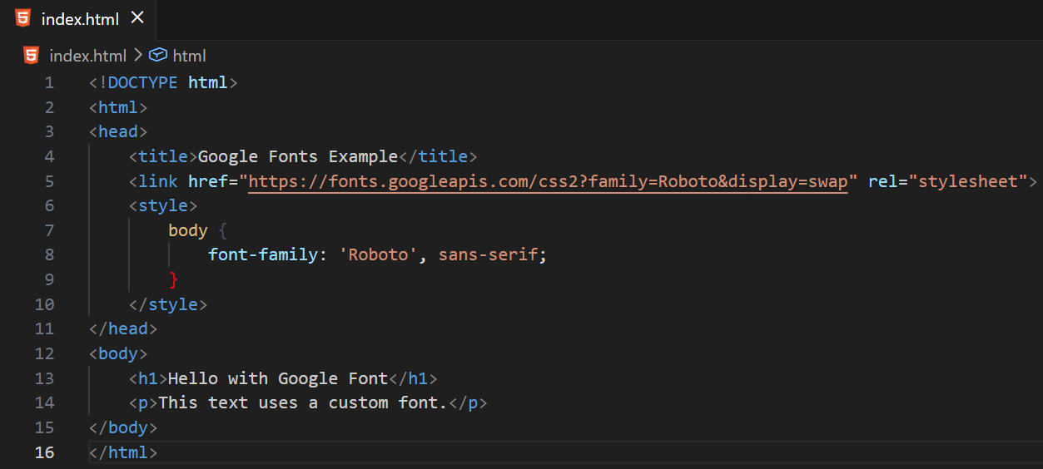
<!DOCTYPE html>
<html>
<head>
<title>Google Fonts Example</title>
<link href="https://fonts.googleapis.com/css2?family=Roboto&display=swap" rel="stylesheet">
<style>
body {
font-family: 'Roboto', sans-serif;
}
</style>
</head>
<body>
<h1>Hello with Google Font</h1>
<p>This text uses a custom font.</p>
</body>
</html>
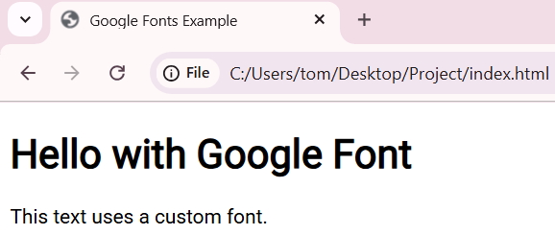

⚡ 4. Preloading Resources (Performance)
# Source: AI Source: Provided by: [Data Path: Persons Table -> ID Column: 1, Name_En Column: Motasem Essam] -> From: [ChatGPT] on [5/6/2026]
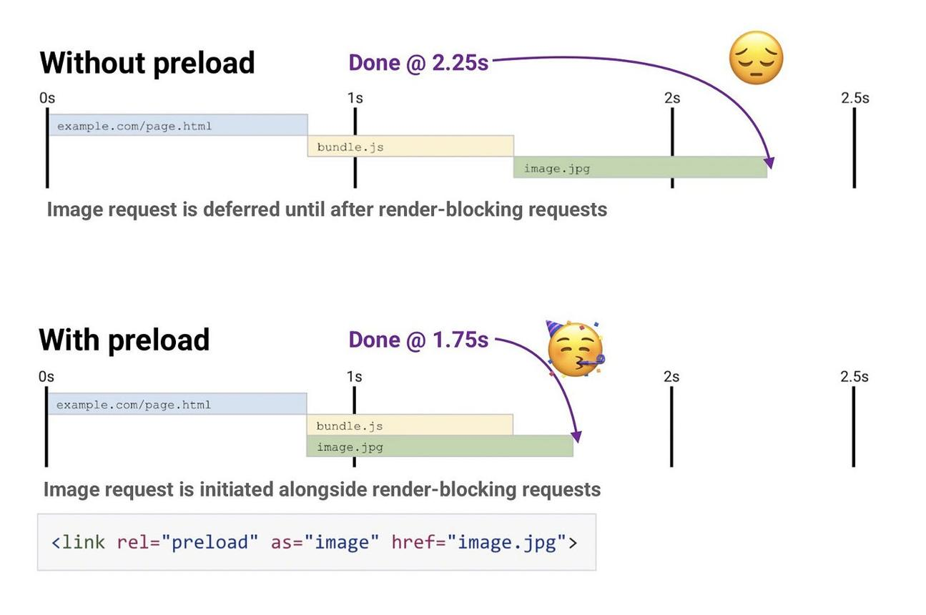
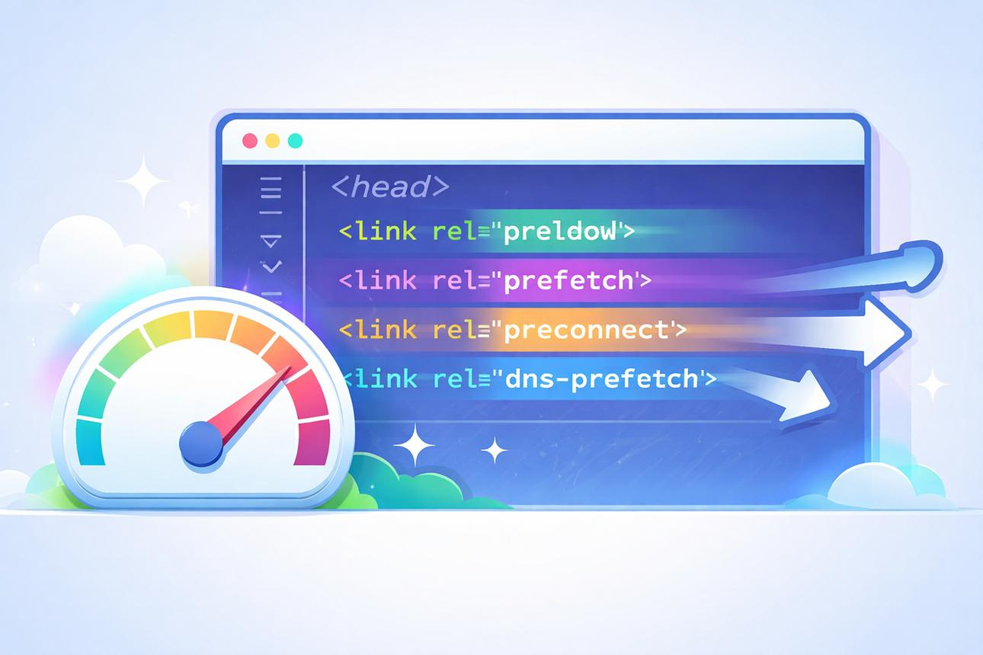
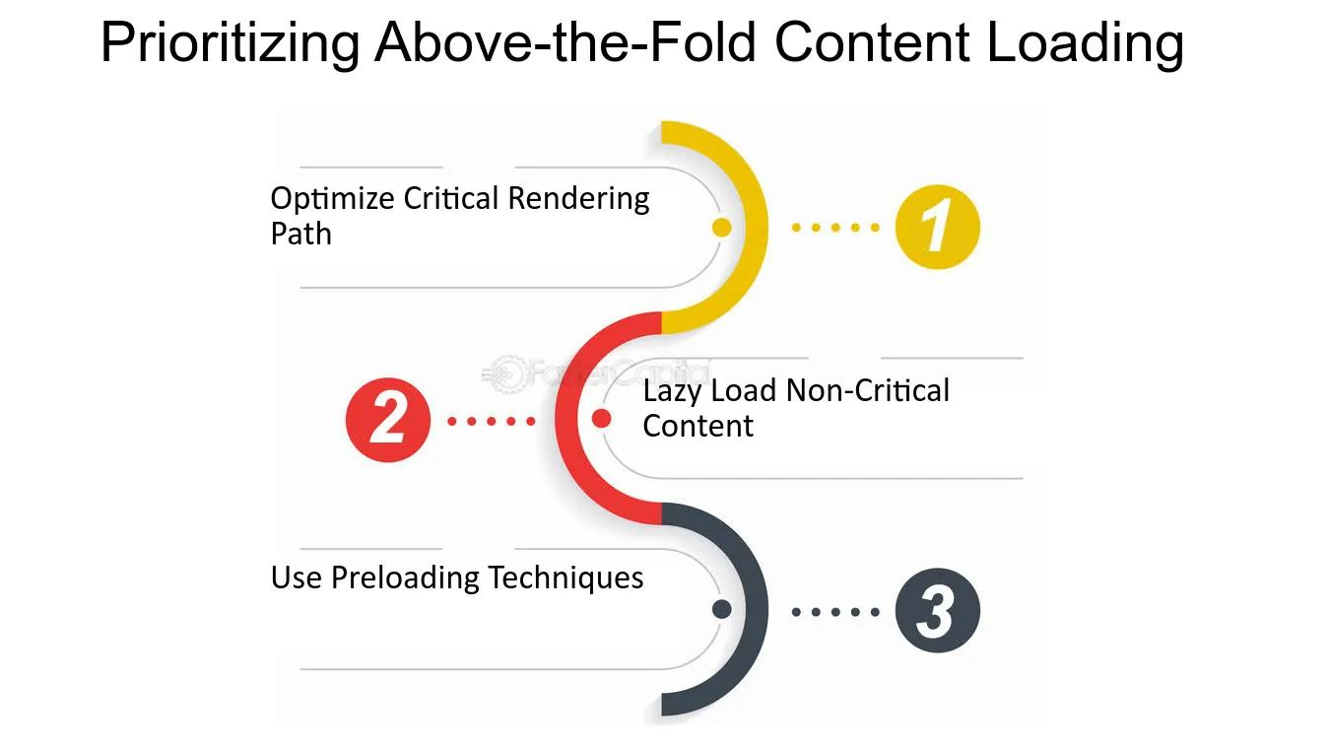

Full Example
# Source: AI Source: Provided by: [Data Path: Persons Table -> ID Column: 1, Name_En Column: Motasem Essam] -> From: [ChatGPT] on [5/6/2026]
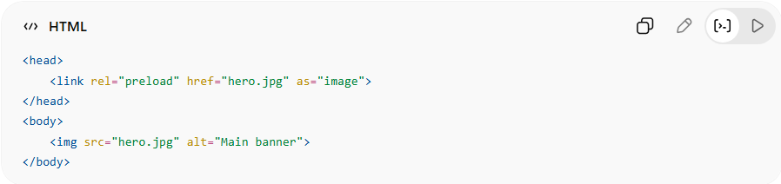
<head>
<link rel="preload" href="hero.jpg" as="image">
</head>
<body>
<img src="hero.jpg" alt="Main banner">
</body>
👉 This code tells the browser to load an image in advance so the webpage loads faster and feels more responsive.

Real Example
# Source: ScreenShot Source: Provided by: [Persons Table -> ID Column: 1, Name_En Column: Motasem Essam] -> Tool: [Automation Table -> ID Column: 16, Name_En Column: Screen Capture] -> From [Operating System: Windows] on [5/6/2026]
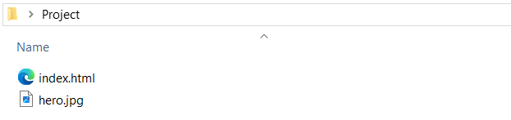
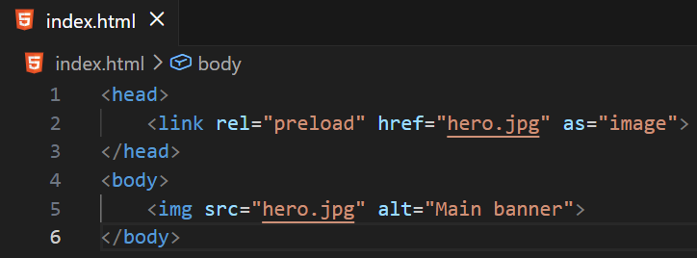
<head>
<link rel="preload" href="hero.jpg" as="image">
</head>
<body>
<img src="hero.jpg" alt="Main banner">
</body>
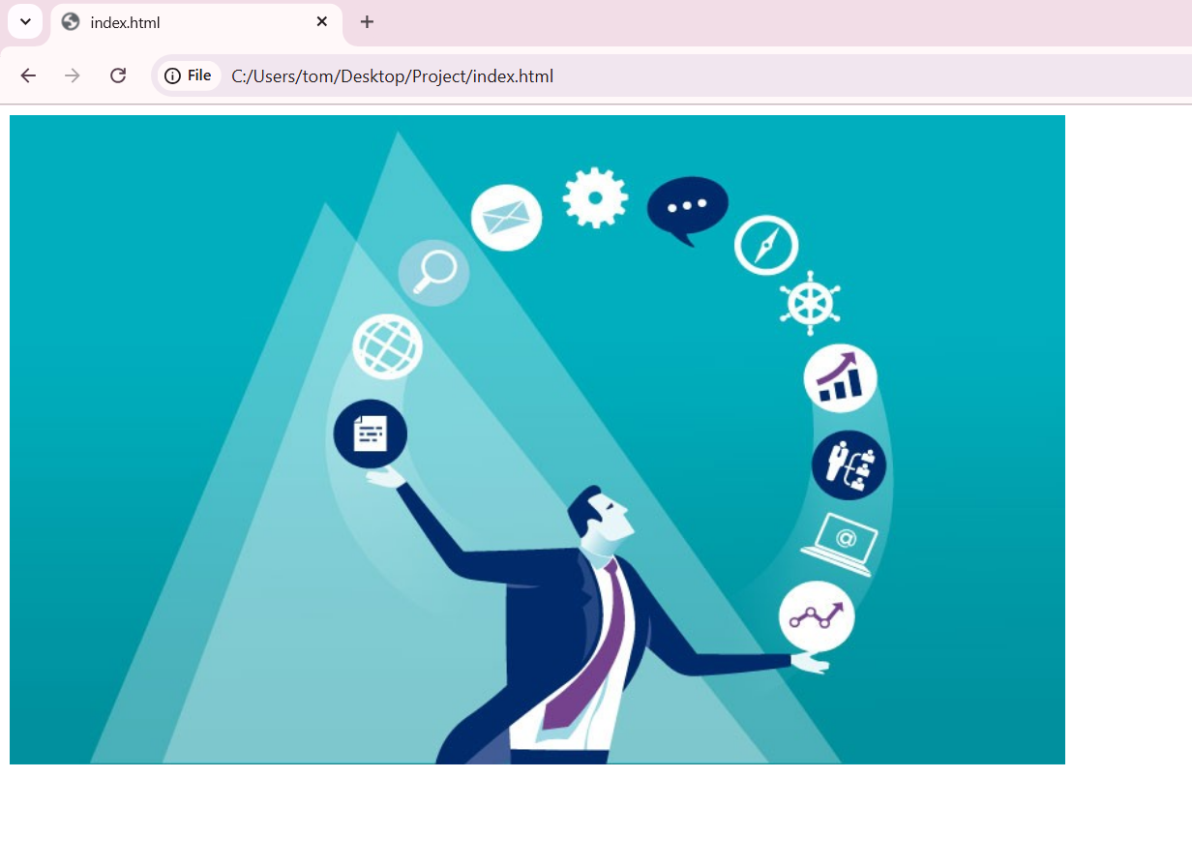

🚀 In short:
# Source: AI Source: Provided by: [Data Path: Persons Table -> ID Column: 1, Name_En Column: Motasem Essam] -> From: [ChatGPT] on [5/6/2026]
The HTML <link> element connects your webpage to external resources like CSS, icons, fonts, and performance files.

